RACE DESCRIPTION:
The race will be held in Thompson Park, which is jointly managed by the US Forest Service and Butte-Silver Bow, near US Hwy 2 south of Butte. The course is a 7.3-mile loop comprised of 60% double-track and 40% single track. Registration is from 10:00 AM – 10:45 A.M; the race will begin at 11:00 A.M.

All Expert category racers must have an annual license.
All USAC Rules Apply
- Registrtion On-line provide by Sports Base On-line $20 – Juniors Free
- Race Day Registration Available - $25
- Racing Starts at 11:00 AM
- Promoters reserve the right to combine classes
- One-day license will be available.
- Prizes for all categories – Prizes must be collected at Awards Ceremony (no winnings will be mailed).
- Official – Dave Wagner

DISTANCES:
Pro/Semi-Pro/Expert Men 11:00 AM 3-Laps
Pro/Semi-Pro/Expert Women 11:00 AM 3-Laps
Sport Men 11:05 AM 2-Laps
Sport Women 11:05 AM 2-Laps
Sport Juniors 11:05 AM 2-Laps
Beginner Men 11:10 AM 1-Lap
Beginner Women 11:10 AM 1-Lap
Beginner Juniors 11:10 AM 1-Lap

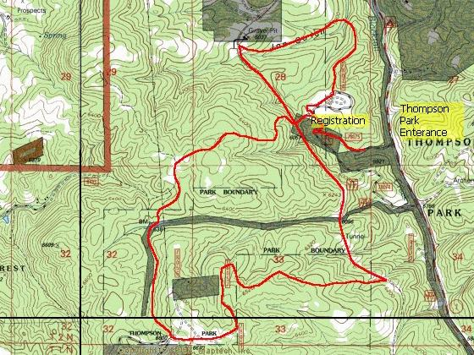
Directions to Thompson Park
Take the Harrison exit (Exit 127A) south on Harrison Ave for 2.9 miles. At the intersection of State Route 2 and Harrison Ave., turn southeast for approximately 4-miles (1-mile past the intersection of Continental Drive and State Route 2). Signs will mark the turn-off to Thompson Park.
FOR INFORMATION CONTACT:
Warren Smith - (406) 494-2979
Email: chirobike@hotmail.com
Web site: www.highlandscycling.org

